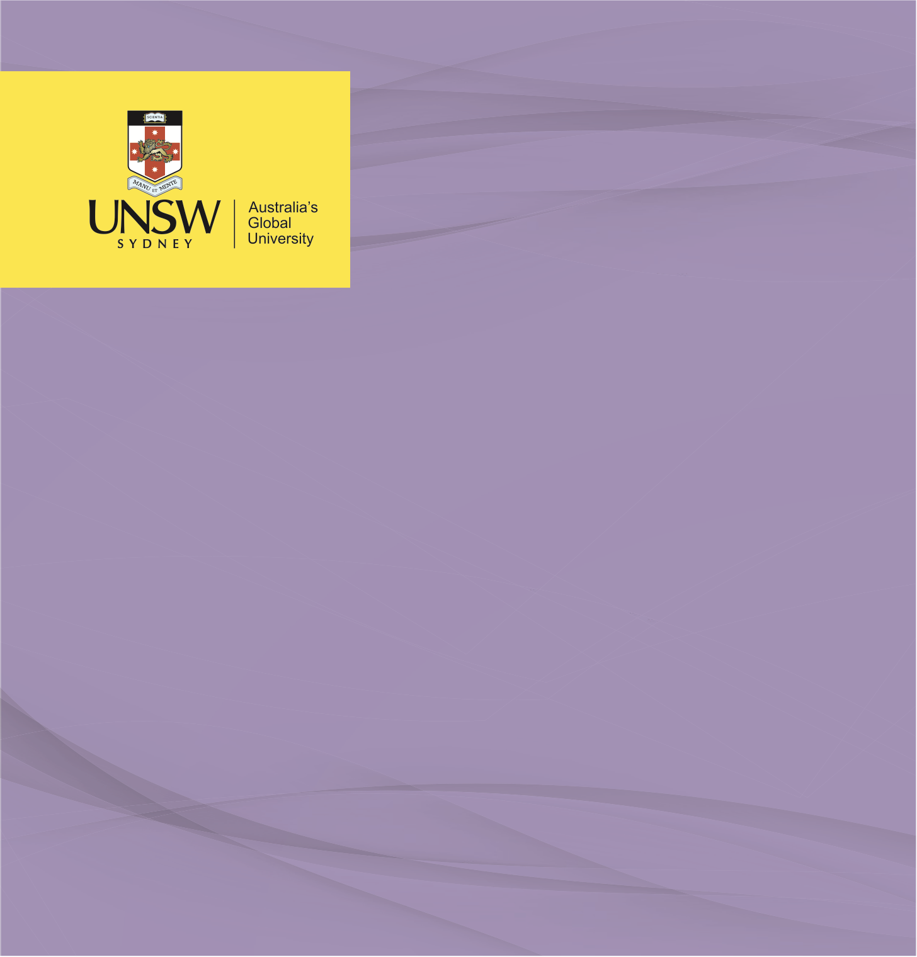

RISK ANALYSIS

**Environmental Risk Analysis: East Gippsland Bushfires (2019-2020)**

**Environmental & Occupational Health**

Nicholas Tanner, November 2022

**Environmental Risk Analysis – East Gippsland Bushfires**

**Introduction**

Following three years of drought conditions in East Gippsland, a series of lightning strikes enkindled the region during the Australian Summer of 2019-2020 (Werbeck & Romo, 2020). By the 2nd of January, 2020 a State of Emergency was declared, displacing up to 100,000 residents of the area from their homes, of which thousands were damaged or destroyed (Australian Broadcasting Authority [ABC] News, 2020; Ryan, 2020). The fires devastated Gippsland throughout the entirety of January and most of February, directly resulting in five deaths, and a critical factor in more than 400 more, in addition to an increase of 3000 emergency department [ED] presentations in comparison during the corresponding two-month period in the preceding year. Ninety-one days after starting, the fires were declared contained on February 20, 2020, by this time, 7.4 million hectares of land had been burnt (ABC News, 2020; Rodney et al., 2021).

This paper will analyse the Gippsland bushfires impact to the region’s ecosystems, specifically the detrimental ecological disturbance factors; in particular the impacts to air, soil and water and the corresponding potential risks to human health.

**Air Impact**

In the presence of bushfires, a number of changes occur to the air, both in the immediate vicinity and surrounding areas. This shift was measured throughout Victoria by way of air quality index testing, with air pollution levels rated as hazardous 54% of days in the two-month period from mid-December to mid-February, 2020 (Rodney et al., 20201). The predominant cause of this air pollution was due to the incomplete combustion of fuels by the fire, resulting in smoke. Smoke is the conglomeration of gases and airborne particulate matter, comprising over 200 different chemicals, some of which are carcinogens (Chua, 2019). Those exposed to hazardous levels of air pollution can be subject to a number of associated health impacts. Exposure to smoke can cause acute effects including irritation of the eyes, nose and throat and nausea arising from the odour. Those with pre-existing cardiovascular and pulmonary conditions are susceptible to acute exacerbation (Pederson, 2018; Slaughter 2014). This was evidenced by an increase of 3150 local hospital emergency department presentations for cardiovascular and respiratory symptoms when compared with the corresponding time period a year earlier (Rodney et al., 2021). Long-term exposure to smoke can also lead to an increased risk of lung disease and mortality (Pederson, 2018)). The human health impact of bushfire smoke is wide-reaching, with 90% of those surveyed in the East Gippsland region reporting at least one physical symptom, most commonly eye and throat irritation. The health impact is not restricted to physical symptoms however, 80% of those surveyed reported increases in their levels of anxiety and/or depression (Rodney et al., 2021). The gaseous components of smoke each have potential consequences for human health, some examples are shown in table 1.

**Table 1**

*Gaseous Compounds, Volatile Organic Compounds, and Particulate Matter and their Potential Health Impacts*

|  |  |
| --- | --- |
| Gas | Potential Health Impacts |
| Carbon Monoxide | Binds to haemoglobin, inhibiting the release and transport of O2 to tissues, results in; fatigue, nausea, visual impairment, dizziness, loss of fine motor control, neurological damage, and death. |
| Carbon Dioxide | Headaches, dizziness, restlessness, difficulty breathing, seating, elevated BP, elevated HR, death. |
| Sulphur Dioxide | Decreased lung function, bronchoconstriction, respiratory symptoms, eye irritations, and adverse pregnancy outcomes. |
| Nitrogen Oxides | Eye, nose and throat irritation, decreased lung function, and respiratory infections in children. |
| Benzene | Eye, nose and throat irritation, decreased lung function, respiratory infection in children. |
| Toluene | Eye and nasal irritation, tiredness, confusion, dizziness, fatigue, pupil dilation, neurological symptoms, insomnia, and liver and kidney damage. |
| Ozone | Decreased lung function, increased airway resistance, impaired lung development in children, exacerbation of asthmatic symptoms. |
| Particulate Matter | Impaired respiratory and cardiac function, inflammation, immune deficiency, death. |

(World Health Organisation [WHO], 2022)

**Soil Impacts**

The soil is also significantly affected when exposed to bushfires, the intensity with which the East Gippsland bushfires burned resulted in surface plants and organic matter being reduced to ash, resulting in up to 10cm of loose soil. This loss of vegetation results in a loss of stability of the landscape and as rains wash away the burned matter and topsoil, heavy metals such as zinc, nickel, lead, copper and arsenic rise closer to the soil’s surface (The Commonwealth Science and Industrial Research Organisation [CSIRO], 2021). Agricultural land made up over half a million hectares of the scorched earth, and with heavy metal contaminating the soil, they may enter the crops and due to their bio-accumulative properties subsequently progress through the food chain, whether from livestock feeding on the crop or directly through human consumption (CSIRO, 2021). The symptoms of heavy metal toxicity to human health can include; abdominal pain, fatigue, dizziness, nausea, dehydration, diarrhoea and neurological symptoms such as dystonia or affected gait (Dennekamp & Abramson, 2011; Hamon et al., 2020). The burning of agricultural crop also impacts upon crop availability both in the short-term but also in the medium to long-term where the ground becomes infertile. This can lead to significant increase in produce costs and result in consumers purchasing cheap less nutritious alternatives, potentially impacting upon nutritional balance which in itself can cause a number of physical symptoms such as lethargy, tooth decay, underweight or obesity, and constipation or diarrhoea (The Centers for Disease Control and Prevention [CDC], 2020). Furthermore, the loss of income to those holding the agricultural lands may lead to a similar inability to acquire adequate nutrition in addition to mental strains which can accompany financial strains.

Further to the potential impacts of bushfire on agricultural land and the linked human health impacts are the numerous ecological impacts associated with bushfires. Heat and the deposition of ash alter the pH of the soil in addition the nutrient availability. Furthermore, damage to the microbes of the ecosystem result in soil sterilisation, impacting the health and regenerative capacity of native flora. This soil sterilisation is exacerbated by disruption to the nutrient and organic matter cycles of the soil ecosystem and an increased hydrophobicity reducing the water available for flora regrowth (CSIRO, 2021). The combustion of organic carbon and other chemicals in high temperatures can also result in the conversion of these soil nutrients into soluble form causing soil leaching, which in turn further reduces the productive capacity of soil. The erosion of the land and soil results in a significantly increased risk of further erosion and runoff in the presence of rain (Australian Water Association [AWA], 2021).

**Water Impacts**

Rain is often invaluable in the subjugation of bushfires, however rain following bushfire can be devastating for the environment, triggering erosion events and debris flow. Sediment runoff occurs in high mass with the unconsolidated, saturated debris flowing into surrounding water systems, in East Gippsland this occurred into a number of rivers and streams throughout the region (Australian Academy of Science [AAS], 2020). The high sediment loads following the bushfires contained high levels of ash and charcoal which upon entering the water systems immediately impacts water quality and can have a protracted effect, with the Cotter River catchment still not recovering from drops in water quality from bushfires ten years ago. (Biswas et al., 2021) A multitude of changes are associated with the sediment runoff. A notable change in turbidity occurs, as sediment and ash smother the rocks, particularly detrimental to the invertebrates of the ecosystem which rely on the stony streams. The heavy metals previously discussed rising to the topsoil also causes significant damage to the water ecosystems as they enter water systems, an example is duckweed growth slowing by up to 60% following seven days of exposure (CSIRO, 2021) Duckweed is an integral component in multiple ecosystems, it serves as livestock feed, a habitat for wildlife, improves water quality by acting as a purifier and reducing turbidity, and is a sustainable food source (Körner & Vermaat, 1998).

Sediment runoff is of greatest concern in freshwater ecosystems, where bacteria in the water consume carbon from ash and in the breakdown process, consume dissolved oxygen (CSIRO, 2021). The more carbon in the system, the more oxygen is removed. Animals and plants in freshwater systems have a very low tolerance for change and cannot survive in low oxygen environments, being unable to breath, breed or feed (AWA, 2021). As with the damage to agricultural land, the same economic and human health impacts apply with large consequences to the food chain and potential loss of income. Like heavy metal bioaccumulation on agricultural ground, the heavy metal runoff into water systems also leads to bioaccumulation and in turn biomagnification. In addition to heavy metals, chemical runoff from the ash considerably increases. Water testing in the Gippsland River following the bushfires showed daily peak loads of; 145 tonnes of dissolved organic carbon, 33 tonnes of nitrogen – an increase from usual daily load of 0.1 to 1 tonne, 6.5 tonnes of phosphorous, an increase from 0.01 to 0.1 tonnes at normal daily levels (Murray-Darling Basin Authority [MDBA], 2021). The nutrient loading from the burnt catchments into the Gippsland River resulted in increased internal loading, drastically increasing the number of cyanobacteria present. Cyanobacteria presence can cause taste and odour problems in fresh water, and in significant concentrations is toxic to human health. The potential toxic effects can include stomach pain, headaches, diarrhoea, vomiting, and neurological symptoms such as dizziness and muscular weakness (CSIRO, 2017).

A secondary consequence of this toxicity is the optimal response being boiling water or drinking bottled water, with the tap water in Australia containing fluoride, potential fluoridation deficiencies may arise if prolonged toxicity of the water supply endures (Water Quality Australia, 2020).

Dead animals also transfer into rivers and lakes in the runoff, this furthers bacterial growth further shifting the bushfires impact from the land to the water systems (CSIRO, 2021). The following (Figure 1) depicts a number of processes which result in water quality deterioration and ecosystem damage after a bushfire.

**Figure 1**

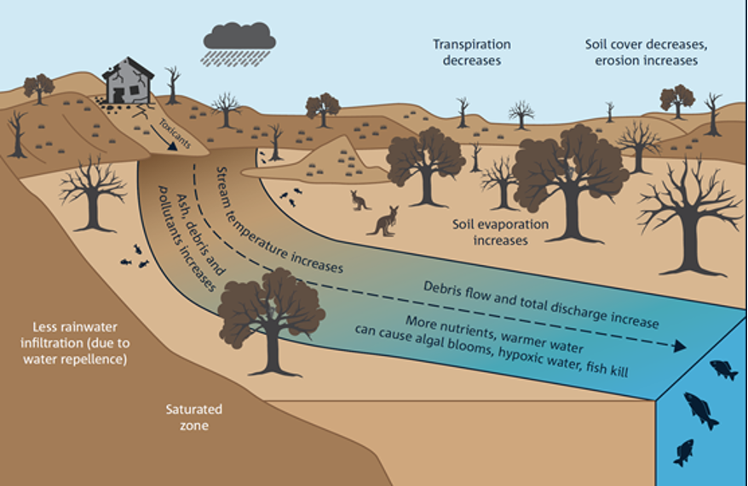(Farrell & Prober, 2022)

**Additional Effects**

The impacts to ecosystems and human health are not restricted to the pollution of air, soil and water. Bushfires have the potential to deal significant damage to infrastructure, including electrical infrastructure. The loss of electricity presents a number of risks to human health, and with the physical barrier that fire presents and the rural locality of some affected regions, it can be extended periods of time before power is restored. A loss of electricity can impact human health in a number of ways, including food hygiene concerns as food begins to decay in the hot conditions and with refrigeration not working, bacteria begin to form such as Salmonella and if contaminated food is consumed, the following physical symptoms may present; diarrhoea, stomach cramping, nausea or vomiting, headaches, chills, and fever (CDC, 2022).

Transport and transport infrastructure are also often damaged, or inaccessible as a result of bushfires and this can impact human health in a number of ways. Transport is frequently used to secure income, whether it be transporting goods or travelling to work. Without income, goods and services may not be afforded and as previously discussed nutritional balance is potentially impacted. The rural locality of parts of Gippsland also means that with transportation infrastructure damaged there may be no way of obtaining required goods for extended timeframes including food and medicine, nor reaching medical facilities for more specialised remedy.

The bushfires were not able to be contained and this resulted in a significant loss of homes, whether totally destroyed or significantly damaged. The threat to properties meant that 200,000 people were temporarily displaced, sheltering in shared evacuation points, rising disease transmissibility conditions, and the spread of disease increasing (Department of Health Tasmania [DoHTAS], 2020). Income loss also impacts human health where it is the source or facilitator of income. Mental distress, particularly anxiety is prevalent, where home security is in jeopardy from bushfires (Rodney, 2021).

Finally, ecosystems are more than just the flora which make them up, but the fauna too. There was an estimated one billion animal deaths in the East Gippsland region not including insects or invertebrates, significantly disrupting the associated ecosystems (Canning, 2020).

**Conclusion**

The 2020 East Gippsland bushfire caused immense ecosystem damage, to the air, the soil and the water systems in the region and its surrounds. The effects of bushfire are felt long after the fires themselves have been extinguished. These natural disasters have a vast capacity to impact upon human health in a multitude of ways, both physically and psychologically and the impacts are not limited to acute effects but chronic impacts too. The damage resulting from bushfires is not limited to the affected regions only, but via waterways and agricultural systems, has the potential to impact upon human health and ecosystems on a much greater scale.

**References**

Australian Academy of Science. (n.d.). (issue brief). *After the Bushfires: Addressing the Health Impacts* (pp. 1–4). Retrieved November 1, 2022, from https://aahms.org/wp-content/uploads/2022/02/after-bushfires-addressing-health-impacts.pdf.

Australian Broadcasting Commission. (2020, February 20). Huge East Gippsland bushfire that burned for three months finally declared ‘contained’. *ABC News*. Retrieved October 19, 2022, from <https://www>.abc.net.au/news/2020-02-20/east-gippsland-bushfire-contained-after-burning-for-three-months/11982744.

Australia State of the Environment (2021). *National air quality standards: Ambient air quality*. Available from: https://soe.environment.gov.au/theme/ambient-air-quality/topic/2021/national-air-quality-standards

Biswas, T.K., Karim, F., Kumar, A., Wilkinson, S., Guerschman, J., Rees, G., McInerney, P., Zampatti, B., Sullivan, A., Nyman, P., Sheridan, G.J. and Joehnk, K. (2021), 2019–2020 Bushfire impacts on sediment and contaminant transport following rainfall in the Upper Murray River catchment. Integr Environ Assess Manag, 17: 1203-1214.<https://doi.org/10.1002/ieam.4492>

Canning, A *et al*. (2020). *Bushfires and the Risks to Drinking Water Quality: Factsheet.* Water Research Australia, 2020. Available from: https://www.waterra.com.au/publications/document-search/?download=1840

Canning, A *et al.* (2020). *Bushfires and the Risks to Drinking Water Quality: Factsheet*. Water Research Australia, 2020. Available from: https://www.waterra.com.au/publications/document-search/?download=1840

Department of Health Tasmania (2018). Preventing spread of disease in areas affected by bushfires. Accessed on 5 March 2020. Available from: https://www.dhhs.tas.gov.au/publichealth/alerts/public_health_updates/preventing_spread_of_disease_in_areas_affected_by_bushfires

Farrell, M., & Prober, S. (2022, May 9). *Recovery of Australia's soils following bushfires*. ECOS. The Commonwealth Science and Industrial Research Organisation. Retrieved November 1, 2022, from https://ecos.csiro.au/soil-fire-recovery/

Gibbs L, *et al*. (2016). *Beyond Bushfires: Community Resilience and Recovery Final Report*. November 2016, University of Melbourne, Victoria, Australia.

Murray-Darling Basin Authority (2021). Bushfire runoff impacting water quality in Hume Dam and downstream.<https://www.mdba.gov.au/media/mr/bushfire-runoff-impacting-water-quality-hume-dam-downstream>

Pan, S-C et al. (2020). Association between air pollution exposure and diabetic retinopathy among diabetics. Environmental Research, Volume 181, February 2020, 108960.

Pedersen, JE (2018). Risk of asthma and chronic obstructive pulmonary disease in a large historical cohort of Danish firefighters. Occup Environ Med. 2018 Dec;75(12):871-876.

Rodney, R. M., Swaminathan, A., Calear, A. L., Christensen, B. K., Lal, A., Lane, J., Leviston, Z., Reynolds, J., Trevenar, S., Vardoulakis, S., & Walker, I. (2021). Physical and mental health effects of bushfire and smoke in the Australian Capital Territory 2019–20. *Frontiers in Public Health*, *9*. https://doi.org/10.3389/fpubh.2021.682402

Ryan, B. (2020, January 2). Bushfires prompt Victorian Premier Daniel Andrews to declare state of disaster as blazes bring ‘unprecedented risk’. *ABC News*. Australian Broadcasting Commission. Retrieved October 20, 2022, from <https://www.abc.net.au/news/2020-01-02/bushfires-victoria-state-of-disaster-declared/11838290>.

Slaughter, JC (2014). Association Between Lung Function and Exposure to Smoke Among Firefighters at Prescribed Burns. J Occup Environ Hyg. 2004;1(1):45-9.

Victoria State Government (2020). *Health concerns related to Victorian bushfires*. Published 24 January 2020. https://www2.health.vic.gov.au/about/news-and-events/healthalerts/health-concerns-bushfires

Water Quality Australia. Bushfires and water quality. (2020) Available from: https://www.waterquality.gov.au/issues/bushfires

Werbeck, N. & Romo, V. (2020, January 3). *Australians Brace For Flames As ‘Frighteningly Quick’ Bushfires Advance Toward Sydney.* National Public Radio [NPR]. <https://www.abc.net.au/news/2020-01-02/fears-bushfires-in-north-east-victoria-could-merge/11837430>

World Health Organization [WHO] (2006). *Air Quality Guidelines: Global Update 2005. Particulate matter, ozone, nitrogen dioxide and sulfur dioxide*. Copenhagen: WHO Regional Office for Europe, 2006.

Zeig-Owens R, *et al.* (2018) Blood Leukocyte Concentrations, FEV1 Decline, and Airflow Limitation. A 15-Year Longitudinal Study of World Trade Center–exposed Firefighters. Annals of the American Thoracic Society. 2018;15(2):173-83.