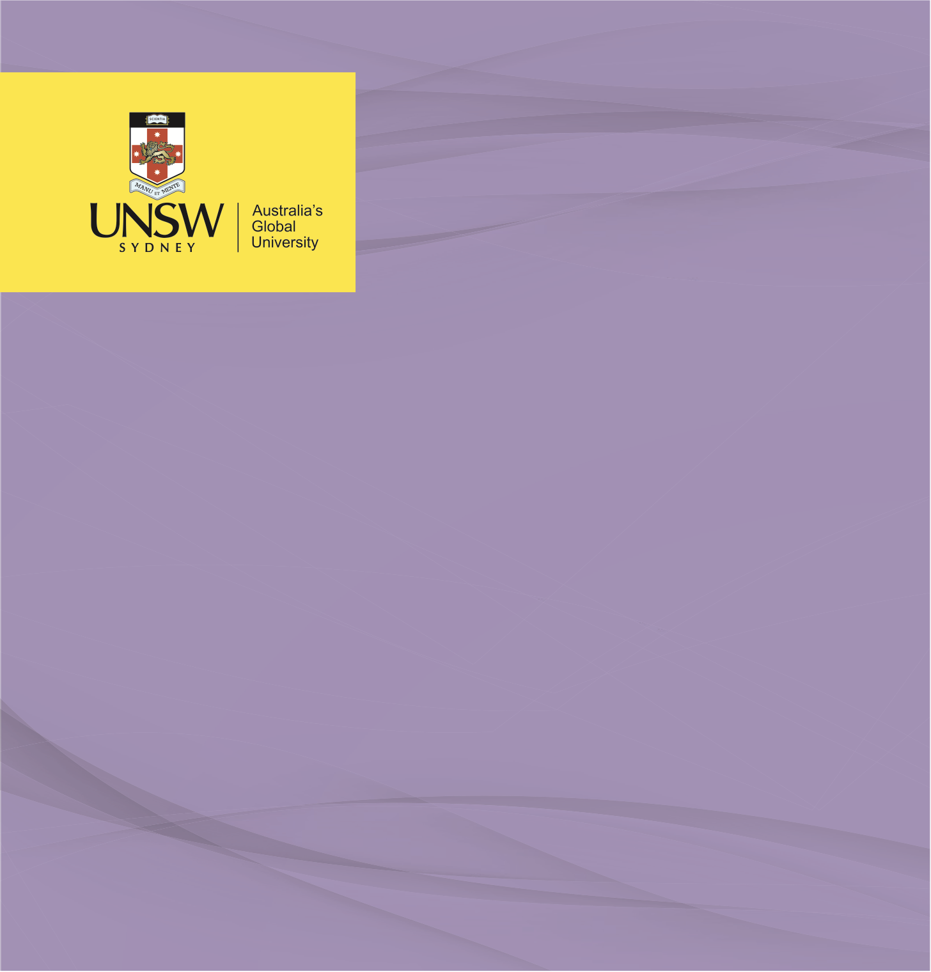

POLICY BRIEF 1

**Culturally Appropriate Indigenous Health Services**

**ATTENTION: Minister for Justice**

Nicholas Tanner, April 2023

**Policy Brief: Culturally-Appropriate Indigenous Health Services**

**Executive Summary**

Minister, Indigenous prisoners in Australia continue to experience significant health disparities in comparison to their non-Indigenous counterparts. The Indigenous prison populations continue to experience poorer physical and mental health outcomes which could be addressed through increased access to culturally appropriate healthcare services whilst incarcerated. These disparities are rooted in a complex interplay of historical, social, and cultural factors, including the impacts of colonisation, discrimination, and intergenerational trauma on health (Australian Institute of Health and Welfare [AIHW], 2020). The current approach to healthcare provision in correctional facilities is proving inadequate in addressing the unique needs of Indigenous prisoners, leading to suboptimal health outcomes and perpetuating existing health inequalities (Inspector of Custodial Services, 2021). It is critical to implement policy changes which focus on providing culturally appropriate health services for Indigenous prisoners, fostering trust, and promoting better health outcomes.

This policy brief recommends a comprehensive strategy to overhaul Indigenous health services in prisons, including;

* Strengthening collaboration with Aboriginal Community Controlled Health Organisations (ACCHOs),
* Increasing funding and support for ACCHOs in correctional facilities,
* Implementing ongoing cultural competence training for healthcare staff,
* Monitoring and evaluating the impact of culturally-appropriate health services, and
* Fostering community engagement and support.

Through the implementation of these recommendations, the Australian government can work towards ensuring that Indigenous prisoners receive culturally appropriate healthcare, addressing health disparities, and promoting social justice and equity within the correctional system.

**Context and Importance of the Problem**

Inadequate access to culturally-appropriate health services for Indigenous prisoners in Australia has reached a critical point and requires immediate attention and action. Indigenous Australians make up approximately 3.3% of the country's population but constitute a staggeringly disproportionate 28% of the adult prison population (Australian Bureau of Statistics [ABS], 2021). This over-representation of Indigenous Australians in the criminal justice system is further compounded by their increased health burden, specifically with regards to; ‘chronic health conditions, mental health issues, and substance abuse disorders compared to their non-Indigenous counterparts’ (Sivak et al., 2017). The issue in focus is the urgent need to provide culturally-appropriate health services through the incorporation of ACCHOs into the correctional institution ecosystem to address these disparities and improve the health outcomes of Indigenous prisoners.

The root causes of this problem can be traced to historical and systemic issues that have marginalised Indigenous communities, including; “colonisation, cultural oppression, and a lack of self-determination in health service provision” (Gee et al., 2014, p. 62). Additionally, the over-representation of Indigenous Australians in the criminal justice system, coupled with inadequate access to health services tailored to their needs, exacerbates the health disparities experienced by this population (Hickey, 2021).

The policy implications for the lack of culturally-appropriate Indigenous health services in correctional institutions are far-reaching and significant, impacting not only the health and well-being of Indigenous prisoners but also the broader Indigenous community and Australian society as a whole. Addressing the need for culturally-appropriate health services for Indigenous prisoners is crucial to promoting equity in health outcomes, reducing rates of recidivism, and fostering positive relationships between Indigenous communities and the Australian government (Lloyd et al., 2015). The provision of health services through ACCHOs is a key step towards achieving these goals, as they are uniquely positioned to deliver culturally-appropriate care that is responsive to the needs of Indigenous Australians (Dwyer, Boulton & Lavoie, 2019).

**Critique of Policy Options**

Review of the existing policy reveals that the current approach to addressing Indigenous health needs in correctional facilities primarily consists of mainstream healthcare services, which are not specifically tailored to Indigenous cultural needs (Inspector of Custodial Services, 2021). Furthermore, there is a lack of integration and collaboration between correctional facilities and Aboriginal Community Controlled Health Organisations (ACCHOs) in the provision of health services for Indigenous prisoners (Dwyer, Boulton & Lavoie, 2019).

The current approach to health service provision for Indigenous prisoners is failing for several reasons. Firstly, the mainstream health services offered in correctional facilities often do not take into account the unique cultural, historical, and social contexts that influence the health of Indigenous Australians, which can lead to inadequate or inappropriate care (Inspector of Custodial Services, 2021). The March 2021 Inspector of Custodial Services Report highlights the barriers Indigenous prisoners face in accessing appropriate healthcare, including a lack of cultural safety, inadequate staffing, and insufficient training of healthcare professionals in cultural competence (Inspector of Custodial Services, 2021).

Secondly, the foremost guiding principle of healthcare for incarcerated Indigenous persons is ‘equal treatment for everyone’ is fundamentally flawed (Kendall et al., 2020). Indigenous health outcomes are not ‘equal’ to that of non-Indigenous within the prison system. In the pursuit of ‘equitable healthcare’ Indigenous prisoners must overcome multiple barriers including deep-rooted, trauma-informed distrust of Western healthcare systems (Kendall et al., 2020). Furthermore, Western healthcare models have proven limitations even in the community setting, to address the disparate health outcomes experienced by Indigenous populations (Nolan-Isles et al., 2021). The limited involvement of ACCHOs in the healthcare of Indigenous prisoners is a missed opportunity to leverage the expertise of these organisations in delivering culturally-appropriate care that addresses the specific health needs of Indigenous people (Dwyer, Boulton & Lavoie, 2019). ACCHOs have been demonstrated to be effective in improving health outcomes for Indigenous Australians in community settings, but their potential impact within correctional facilities remains largely untapped (Panaretto et al., 2014).

The shortcomings of existing health services that are not culturally tailored to Indigenous prisoners is further emphasised by the persisting health disparities and poorer health outcomes among this population. A study conducted by Heffernan et al. (2012) found that the prevalence of cognitive impairment among Indigenous prisoners was 3.3 times higher than that of non-Indigenous prisoners. Furthermore, Indigenous Australians in general have a life expectancy that is 8.6 years lower for males and 7.8 years lower for females when compared to non-Indigenous Australians (AIHW, 2020). While these statistics do not solely reflect the experiences of Indigenous prisoners, they do highlight the pressing need for culturally-appropriate health services that can effectively address the complex health challenges faced by this population. In a survey of Indigenous people in custody, 54% reported that they had experienced racial discrimination while accessing healthcare services (Dudgeon et al., 2014). This underscores the importance of providing culturally-appropriate healthcare services, as the lack of cultural sensitivity can deter Indigenous prisoners from seeking necessary care and contribute to the perpetuation of health disparities.

It is important to acknowledge that some improvements have been made in recent years to address Indigenous health disparities in correctional facilities, such as the implementation of Aboriginal Health Impact Statements and cultural awareness training for healthcare staff (Inspector of Custodial Services, 2021). However, these initiatives alone are insufficient to address the complex and persistent health disparities experienced by Indigenous prisoners. The need for a more comprehensive and culturally-appropriate approach to healthcare provision for Indigenous prisoners, which involves greater collaboration with ACCHOs, remains a pressing issue.

**Policy Recommendations**

To address the shortcomings of the current policy approach and improve the health outcomes for Indigenous prisoners, the following specific measures are recommended for implementation:

* Strengthen collaboration between correctional facilities and ACCHOs: Establish formal partnerships with ACCHOs to ensure that Indigenous prisoners have access to culturally-appropriate healthcare services. This collaboration should include co-designing care plans, sharing resources, and delivering joint training for healthcare staff on cultural competence and safety (Dwyer, Boulton & Lavoie, 2019). This recommendation expands on Recommendation 4.4 of the 2021 Inspector of Custodial Services, 2021 Report from New South Wales.
* Increase funding and support for ACCHOs in correctional facilities: Allocate additional resources to enable ACCHOs to expand their services within correctional facilities, including funding for more healthcare professionals, equipment, and culturally-appropriate healthcare programs tailored to the specific needs of Indigenous prisoners (Panaretto et al., 2014).
* Implement ongoing cultural competence training for healthcare staff: Mandate regular cultural competence and safety training for all healthcare staff working in correctional facilities, with a focus on understanding the historical, social, and cultural factors that influence Indigenous health (Inspector of Custodial Services, 2021,).
* Monitor and evaluate the impact of culturally-appropriate health services: Establish a framework for monitoring and evaluating the effectiveness of culturally-appropriate health services for Indigenous prisoners, including the collection of disaggregated data on health outcomes, access to care, and patient satisfaction (South Australia Health, 2021). This should also incorporate the further integration of Indigenous Health Impact Statements for all relevant policies, procedures and guidelines (Inspector of Custodial Services, 2021).
* Foster community engagement and support: Engage with local Indigenous communities and organisations to ensure continuity of care and immediate provision of healthcare needs. This should incorporate both intake into correctional institutions and in the planning and facilitation of reintegration upon release (Biddle & Swee, 2021). This is also in accordance with the 1987 Royal Commission into Aboriginal Deaths in Custody’s recommendation to facilitate the exchange of health data between prison healthcare services and ACCHOs.
* The March 2021 Inspector of Custodial Services Report also suggested collaboration with the Aboriginal Health &Medical Research Council and the Justice Health and Forensic Mental Health Network to develop and implement a research agenda addressing health needs of Indigenous people in custody.

Minister, may I also refer you to South Australia Health’s ‘Model of Care for Aboriginal Prisoner Health and Wellbeing For South Australia 2017 Final Report’ which was prepared by the Wardliparingga Aboriginal Health Research Unit, pp. 10-12 which sets out in more detail recommendations based on collaboration between the Department of Health and the Aboriginal community. These recommendations go into greater specifics as to optimal implementation strategies and look to minimise costs through the use of existing technologies and knowledge which can be implemented such as tracking health care provision through MyGov.

Minister, it is critical to recognise the urgent need for action to immediately address the health disparities experienced by Indigenous prisoners in Australia. By implementing these policy recommendations, we can work towards providing culturally-appropriate health services that cater to the unique needs of Indigenous prisoners, promoting equity in health outcomes, and fostering positive relationships between Indigenous communities and the Australian government. The health and well-being of Indigenous prisoners are vital components of social justice and equity, and it is our collective responsibility to ensure that their healthcare needs are met in a respectful and culturally-sensitive manner.

**References:**

Australian Bureau of Statistics. (2021). Prisoners in Australia, 2020 (Cat. No. 4517.0). https://www.abs.gov.au/statistics/people/crime-and-justice/prisoners-australia/latest-release

Australian Institute of Health and Welfare. (2018). Deaths in Australia (PHE 229). https://www.aihw.gov.au/reports/life-expectancy-death/deaths-in-australia/contents/life-expectancy

Australian Institute of Health and Welfare. (2020). Australia's health 2020: In brief (Cat. No. AUS 232). <https://www.aihw.gov.au/reports/australias-health/australias-health-2020-in-brief/contents/about>

Biddle, N., & Swee, H. (2012). The relationship between wellbeing and Indigenous land, language and culture in Australia. Australian Geographer, 43(3), 215-232. https://doi.org/10.1080/00049182.2012.706201

Dudgeon, P., Walker, R., Scrine, C., Shepherd, C., Calma, T., & Ring, I. (2014). Effective strategies to strengthen the mental health and wellbeing of Aboriginal and Torres Strait Islander people (Issues paper no. 12). Closing the Gap Clearinghouse. https://www.aihw.gov.au/getmedia/44d13a87-4a33-4c25-a3bb-9944a4e8d3c2/ctgc-ip12.pdf.aspx

Durey, A., & Thompson, S. C. (2012). Reducing the health disparities of Indigenous Australians: Time to change focus. BMC Health Services Research, 12, 151. <https://doi.org/10.1186/1472-6963-12-151>

Dwyer, J., Boulton, A., & Lavoie, J. G. (2019). Indigenous peoples' health care: New approaches to contracting and accountability at the public administration frontier. Public Management Review, 21(2), 159-177. <https://doi.org/10.1080/14719037.2018.1438498>

Lloyd, J. E., Delaney-Thiele, D., Abbott, P., Baldry, E., McEntyre, E., Reath, J., Indig, D., Sherwood, J., & Harris, M. F. (2015). The role of primary health care services to better meet the needs of Aboriginal Australians transitioning from prison to the community. *BMC Family Practice*, *16*(1). https://doi.org/10.1186/s12875-015-0303-0

Gee, G., Dudgeon, P., Schultz, C., Hart, A., & Kelly, K. (2014). Aboriginal and Torres Strait Islander Social and Emotional Wellbeing. In P. Dudgeon, H. Milroy, & R. Walker (Eds.), *Working Together: Aboriginal and Torres Strait Islander Mental Health and Wellbeing Principles and Practice*(2nd ed., pp. 55-58). Commonwealth Government of Australia. https://www.telethonkids.org.au/globalassets/media/documents/aboriginal-health/working-together-second-edition/wt-part-1-chapt-4-final.pdf

Heffernan, E., Andersen, K., Dev, A., & Kinner, S. (2012). Prevalence of mental illness among Aboriginal and Torres Strait Islander people in Queensland prisons. Medical Journal of Australia, 197(1), 37-41. https://doi.org/10.5694/mja11.11352

Hickey, S. (2021). Talking back to the research: Indigenous wellbeing and resilience narratives from urban Australia. *Journal of Human Development and Capabilities*, *22*(3), 423-445. https://doi.org/10.1080/19452829.2021.1882966

Inspector of Custodial Services. (2021). Review of Health Services in NSW Correctional Centres. https://www.custodialinspector.justice.nsw.gov.au/Documents/Review-of-Health-Services-in-NSW-Correctional-Centres-March-2021.pdf

Kendall, S., Lighton, S., Sherwood, J., Baldry, E., & Sullivan, E. A. (2020). Incarcerated aboriginal women’s experiences of accessing healthcare and the limitations of the ‘equal treatment’ principle. *International Journal for Equity in Health*, *19*(1). https://doi.org/10.1186/s12939-020-1155-3

Nolan-Isles, D., Macniven, R., Hunter, K., Gwynn, J., Lincoln, M., Moir, R., Dimitropoulos, Y., Taylor, D., Agius, T., Finlayson, H., Martin, R., Ward, K., Tobin, S., & Gwynne, K. (2021). Enablers and barriers to accessing healthcare services for Aboriginal people in New South Wales, Australia. *International Journal of Environmental Research and Public Health*, *18*(6), 3014. https://doi.org/10.3390/ijerph18063014

Panaretto, K. S., Wenitong, M., Button, S., & Ring, I. T. (2014). Aboriginal community controlled health services: Leading the way in primary care. Medical Journal of Australia, 200(11), 649-652. https://doi.org/10.5694/mja13.00005

Royal Commission into Aboriginal Deaths in Custody. (1991). National report: Overview and recommendations. Australian Government Publishing Service. https://www.austlii.edu.au/au/other/IndigLRes/rciadic/

Sivak, L., Cantley, L., Kelly, J., Reilly, R., Hawke, K., Mott, K., Stewart, H., Mckivett, A., Rankine, S., Coulthard, A., Miller, W. and Brown, A. (2017). Model of Care for Aboriginal Prisoner Health and Wellbeing for South Australia – Final Report, Wardliparingga Aboriginal Health Research Unit: SAHMRI Adelaide, South Australia