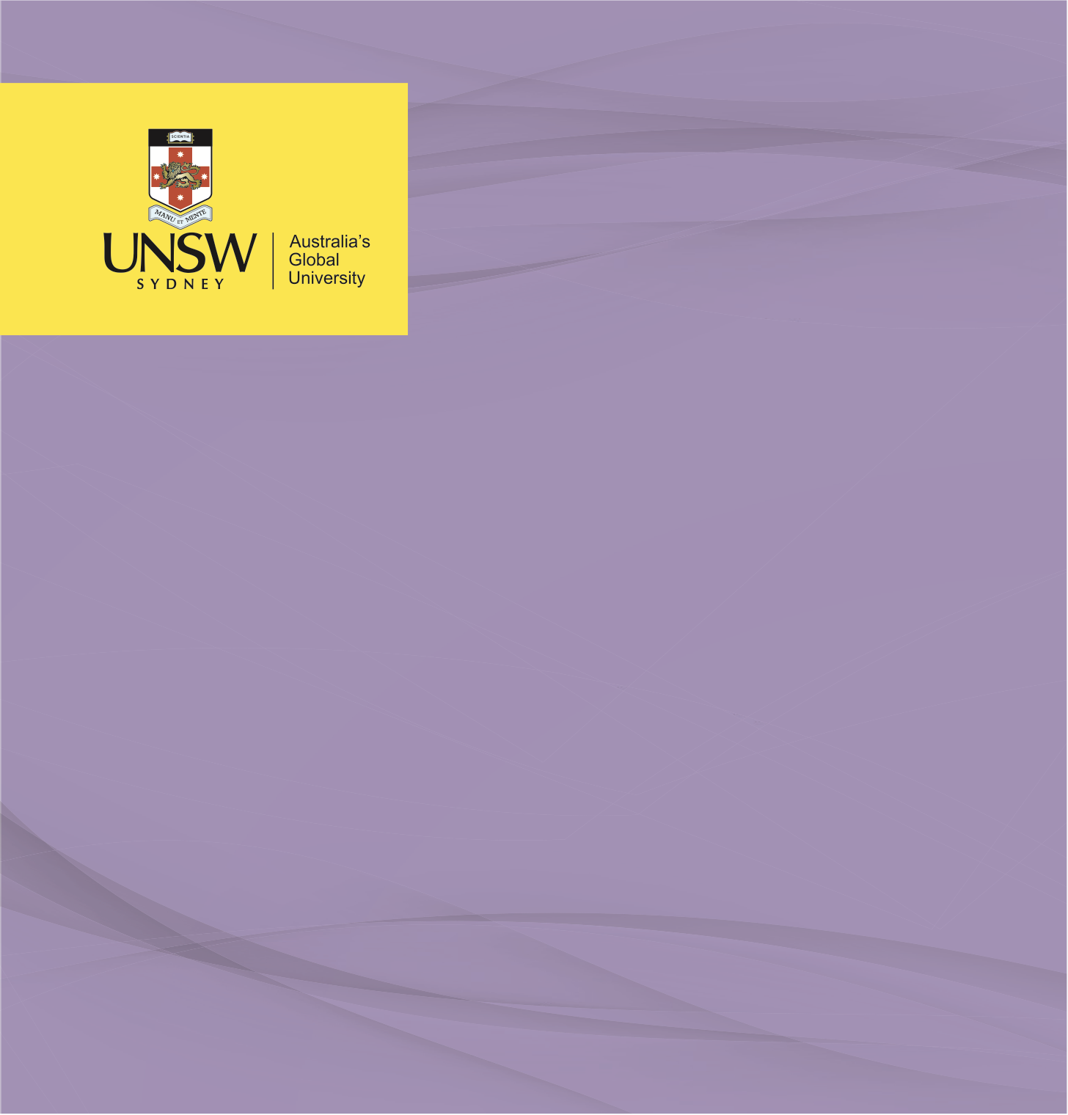

ADVOCACY PITCH

**Elevator Pitch: WASH Bangladesh**

**Health Leadership**

Nicholas Tanner, October 2022

Hi, Mr Majumder my name is Nick, can I firstly say how impressively resourceful and effective your conglomerate has been in accelerating WASH throughout Bangladesh. Would you mind if I take just two minutes of your time to discuss my local health district’s public school and their overwhelmed water and sanitation facilities.

Non-attendance has become an increasingly concerning trend at the school in my local district. As you’re aware the most recent national hygiene survey in 2019 found that 30% of girls were absent for 3 days each and every month due to the lack of menstrual hygiene management facilities. Further to this, with the COVID-19 pandemic revealing the extent to which low- and middle-income nations are struggling, particularly in rural locations to provision appropriate WASH conditions and efforts to control disease spread. This in conjunction with the recent uptake initiatives leading to a significant increase in girls attending primary and early secondary education I am sure you can appreciate the additional strain this has placed on the current facilities we have available.

Naturally this is an issue nationwide, and whilst I know you and your conglomerate strive to introduce WASH to everyone across the country,

I recognise this is a long-term objective. As such an active advocate in this space, here is why a mutually beneficial partnership between our school and community and your collective would be an incredible opportunity. We request your financial and resource provisioning support and in return we are committed to not just the establishment of WASH facilities in our school, but like you we wish to see personal hygiene and infection control rise nationally. Utilising our region, we would be committed to establishing a Bangladesh specific program to accompany improved infrastructure. We would utilise both yours and our contacts at local and federal levels of government to undergo social mapping, providing a framework which will result in providing not just the facilities but accompanying information to the community. For your own research and expenditure improvement we will commit to monitoring progress of the WASH initiative and reporting to the local government institutions as well as your conglomerate for any metrics you believe would be beneficial.

We would like to do our part in promoting gender equality in Bangladesh, and believe that your ability to fund and provision infrastructure would allow us in partnership to unite WASH initiatives with the policy promoting women in education and furthering these objectives to include training on gender inclusion, social inclusion and increased women’s participation in the decision-making processes. The first step towards this is to give our girls every reason to be at school, and improve their level of education and health outcomes.

While it is our goal to reduce to zero the non-attendance rate within our school which is directly correlated to inadequate WASH and MHM infrastructure. Our first objective towards this overall goal is to completely eliminate female students’ absenteeism as a result of a lack of proper MHM facilities.