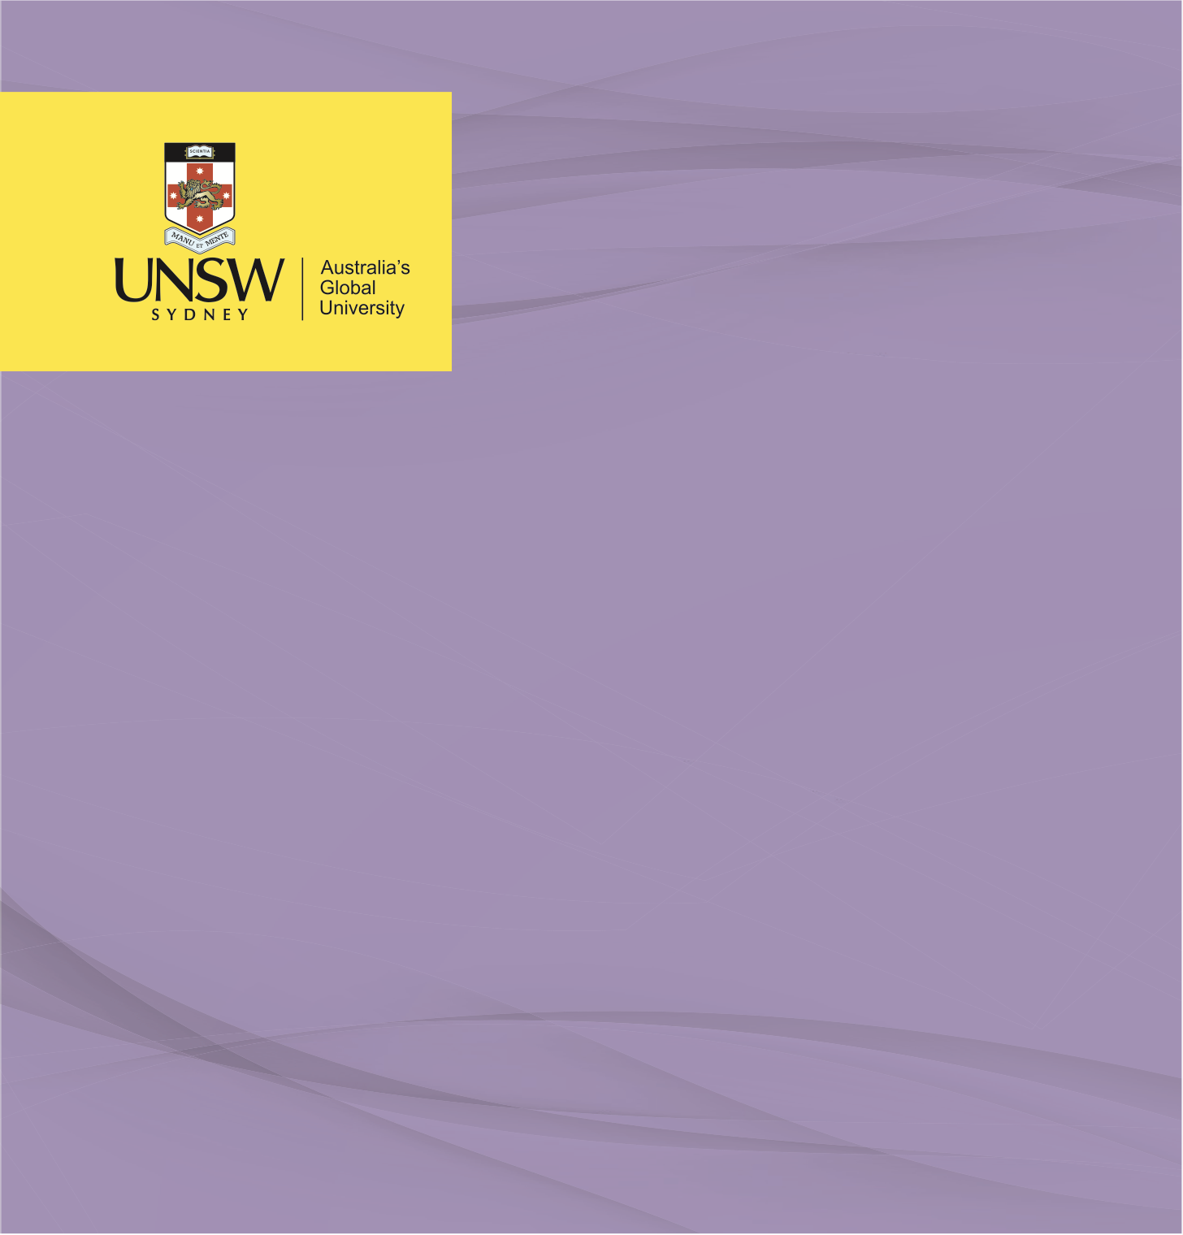

REFLECTION PAPER

**Kenyan STEPwise Health Strategy Plan**

**Principles of Prevention and Public Health Surveillance**

Nicholas Tanner, November 2022

**Kenyan STEPwise Health Strategy Plan – Reflection**

**Part A: Reflection**

Throughout the entirety of this assignment, my understanding of chronic disease and associated risk factors continued to expand through each and every aspect I encountered during my research. Every time I generated a thought as to an obstacle, challenge or benefit of utilising a component of the STEPwise survey instrument, another followed. My appreciation for the consideration given to the implementation of such an instrument also increased exponsentially. It was also an eye-opening experience conducting this thought exercise from the perspective of a lower-middle income nation (Kenya). When financial resources are limited, it is difficult to determine what is and isn’t valuable to include in the provisioning of the surveillance tool.

Also interesting was to consider a nation which is undergoing a double burden of disease. Living in a developed nation, we are well past the time when infectious disease made up a significant proportion of our mortality rate. Being aware of the astronomical burden noncommunicable diseases have on our society, it seems so logical that a significant portion of health expenditure should go towards establishing prevention and control systems. Yet when a country is faced with pre-existing burden of infectious disease which at this point of time is still the leading contributor to mortality, it is far more difficult to simply switch spending priorities. It makes it abundantly clear how important it is to appropriately allocate very limited available resources into the most cost-effective interventions.

I was pleased with the opportunity to further explore the STEPS framework, going through each of the individual components and question groups of the instrument. The information gleamed from the questions was both thought provoking and enlightening in how they were posed, the level of specificity and the factors which were considered valuable in determining status of the behavioural, physical and biochemical risk factors of noncommunicable disease. Further than just reading the question sets and measurement requirements, I read through a completed STEPS report from Pakistan (also a lower-middle income nation). This gave me a really thorough understanding as to the process, the huge logistical and financial challenges, ut perhaps most interestingly the way the data has been utilised since its collection and analysis.b