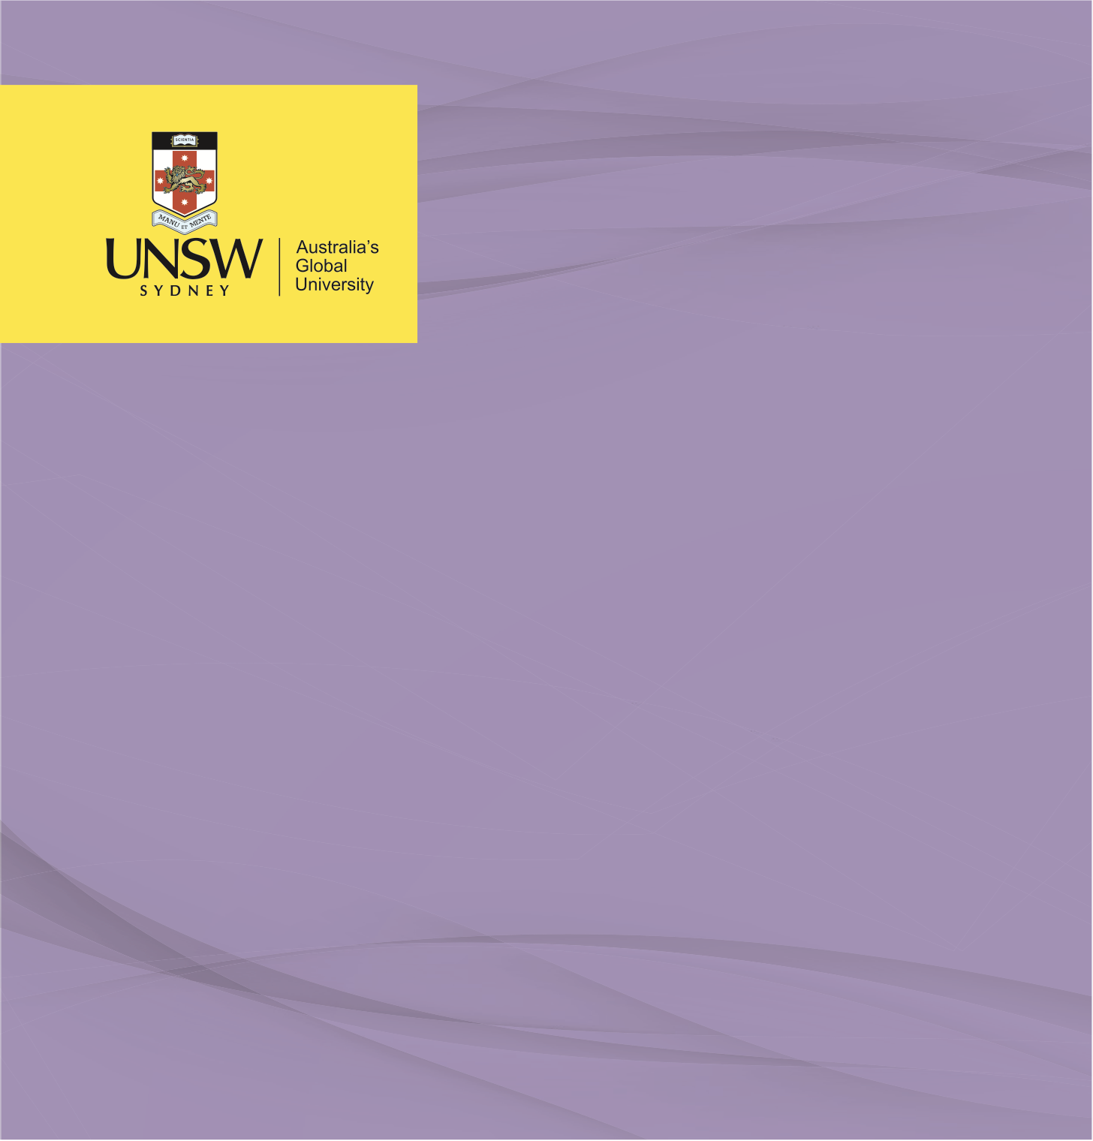

ADVOCACY & STAKEHOLDER ANALYSIS

**Stakeholder Identification and Analysis: Cyclone Winston Response**

**Public Health Policy Programs**

Nicholas Tanner, August 2021

**Stakeholder Identification & Analysis: Cyclone Winston Response**

1. Five groups/actors who had a role in the preparedness/response to Cyclone Winston;
   * 1. Non-government organisations (NGOs), a significant NGO involved in both the preparedness and response to Cyclone Winston was the Red Cross, both the Australian Red Cross and the Fiji Red Cross Society (Robinson, Harris & Ray, 2016).
     2. The Fijian government’s National Disaster Management Office led the preparation and response to Cyclone Winston (World Food Programme, 2016).
     3. International organisations, a key example of an international organisation assisting with the recovery efforts following Cyclone Winston was the United Nations’ World Food Programme (World Food Programme, 2016).
     4. Civil society organisations (CSO) also assisted with the preparations and response to Cyclone Winston, an integral CSO to the recovery efforts was the Fijian Latter-day Saints, establishing a ‘Priesthood & Relief Society (The Church of Jesus Christ of Latter-day Saints, 2016).
     5. The media is another stakeholder which played an important role in the preparations for Cyclone Winston, utilising traditional media in addition to social media to raise awareness and provide information (Finau et al., 2018).
2. The role of three of the afore-mentioned groups;
   * 1. The Australian Red Cross (ARC) played a significant role in both readying Fiji’s response to a natural disaster and in assisting with recovery efforts. A month prior to Cyclone Winston, the ARC ran simulation exercises to assess the logistical requirements for the provision of rapid support to the Fiji Red Cross Society (FRCS). Throughout the simulation, the ARC sought to determine optimal points of contact, gain insight into the existing safety measures and protocols and determine existing infrastructure for the delivery of public messages in times of emergency. After completing this review, the ARC in conjunction with the FRCS implemented reform of processes to optimise future emergency responses (Robinson, Harris & Ray, 2016).
     2. The media played an integral role in the lead-up to Cyclone Winston making land, and then again as the response process commenced. Fiji, is made up of approximately 100 inhabited islands (MacDonald & Foster, 2019), and thus the media have a critical role in the dissemination of information. The media utilised their outreach in preparing Fijians for the incoming cyclone, advising of government shelter locations in addition to sharing Red Cross’s recommendations for preparing properties against cyclones. The media also recognised the difficulty in reaching all of the Fijian communities and encouraged those who saw the emergency broadcasts to provide outreach to more remote communities. With communication infrastructure severely damaged throughout Cyclone Winston and in its aftermath, media outlets utilised alternative mediums, especially social media to provide tracking data and spread critical information (Finau et al., 2018).
     3. The United Nation’s World Food Programme (WFP) responded to requests for food assistance from the Fijian government. The northern islands of Fiji were estimated to have lost between 70 and 80% of their crops as a direct result of Cyclone Winston. WFP provided immediate response during the cyclone with their logistics and ICT divisions laying the foundation for WFP’s emergency operation which commenced two weeks later (World Food Programme, 2016). The WFP assisted the government in meeting emergency food requirements for households in the most severely affected areas. The food assistance efforts were supplementary to the WFP’s role as the agency lead for ‘Logistics and Emergency Telecommunications Clusters’(World Food Programme, 2017).
3. Public health policy encompasses the vast set of decision-making processes, systems of laws and directives which determine both the actions and inaction enacted to maximise targeted health outcomes and promote wellbeing within society. Public health programs involve the coordination of health promotion strategies with the intention of delivering improved health outcomes at a population level. Public health policy and programs form a cyclical relationship. Public health policy is usually developed in response to an issue with targeted outcomes in mind, public health programs ideally are coordinated and comprehensive responses to achieve these health outcomes (Oliver, 2006). Public health policy and programs differ in that policy seeks to achieve an overarching outcome, whereas the programs implemented to achieve this outcome are developed with distinct actions to target specific components. Public health policy also has the benefit of being theoretical in nature, and whilst public health programs are derived from these theoretical constructs, resource allocations often limit the delivery of these programs to only the most cost-effective (Brownson, Chriqui & Stamatakis, 2009).

Governments are often tasked with the development, implementation and evaluation of public health policy and programs. However, governmental decision makers are often given direction by external interest groups who are able to exert influence over their policy decisions. Influence varies in strength, with the control of resources being a key determinant. The WFP acted from a position of power in their negotiations with the Fiji Government for the delivery of emergency provisions. The WFP recognised they had the financial, workforce, infrastructure and knowledge capacities to provide the relief Fiji sought in relation to the recovery effort’s logistical direction and food supplies in the months following the significant destruction to the agricultural industry in Fiji during and post Cyclone Winston (World Food Programme, 2016). The WFP exerted their significant influence by inserting compulsory provisions into their agreement. Fiji was used as a test case for the WFP to explore a more cost-effective method of providing food assistance to people affected by emergencies. The Fiji Government was required to use their existing welfare infrastructure, managed by the Department of Social Welfare, with the WFP support distributed as a top-up to the existing support (World Food Programme, 2017). The Fiji Government was also required to participate in evaluation of the WFP scheme. Additionally, involved stakeholders were compelled to work with the WFP to develop improved safeguards and trainings to minimise the island nations’ reliance on support for future disaster relief efforts (World Food Programme, 2017). The WFP could have leaned on their influence and added further stipulations to their support, for example, future funding for infrastructure to provide security against such an extreme percentage of food supply loss. These conditions could be leveraged with the offer for training and educational reform regarding climate change and the increasing potential for severe natural disasters to again devastate crops and livestock.

**References;**

Brownson, R., Chriqui, J., & Stamatakis, K. (2009). Understanding Evidence-Based Public Health Policy. *American Journal Of Public Health*, *99*(9), 1576-1583. doi: 10.2105/ajph.2008.156224

CARE. (2016). *Localisation in Practice A Pacific Case Study: What CARE and local partner Live & Learn have learned from jointly responding to Cyclone Winston in Fiji (October 2016)*. Fiji: OCHA. Retrieved from https://reliefweb.int/report/fiji/localisation-practice-pacific-case-study-what-care-and-local-partner-live-learn-have.

Finau, G., Cox, J., Tarai, J., Kant, R., Varea, R., & Titifanue, J. (2018). Social media and disaster communication: A case study of Cyclone Winston. *Pacific Journalism Review : Te Koakoa*, *24*(1), 123-137. doi: 10.24135/pjr.v24i1.400.

MacDonald, B., & Foster, S. (2019). Fiji. Retrieved 20 June 2021, from https://www.britannica.com/place/Fiji-republic-Pacific-Ocean/additional-info#history

Mansur, A., Doyle, J., & Ivaschenko, O. (2017). *Lessons Learnt from Fiji’s Tropical Cyclone Winston* (pp. 37-40). Washington, DC: The World Bank. Retrieved from https://documents1.worldbank.org/curated/en/143591490296944528/pdf/113710-NWP-PUBLIC-P159592-1701.pdf.

Oliver, T. (2006). THE POLITICS OF PUBLIC HEALTH POLICY. *Annual Review Of Public Health*, *27*(1), 195-233. doi: 10.1146/annurev.publhealth.25.101802.123126.

Robinson, C., Harris, C., & Ray, S. (2016). AJEM Jul 2016 - Case study: How a disaster simulation helped Red Cross prepare for Cyclone Winston | Australian Disaster Resilience Knowledge Hub. Retrieved from https://knowledge.aidr.org.au/resources/ajem-jul-2016-case-study-how-a-disaster-simulation-helped-red-cross-prepare-for-cyclone-winston/.

The Church of Jesus Christ of Latter-day Saints. (2016). *Church Organizes to Help Fiji Heal after Cyclone Winston*. Retrieved from https://www.churchofjesuschrist.org/church/news/church-organizes-to-help-fiji-heal-after-cyclone-winston?lang=eng.

UN Office for Disaster Risk Reduction. (2016). *Fiji’s honest appraisal of Cyclone Winston*. Retrieved from https://reliefweb.int/report/fiji/fiji-s-honest-appraisal-cyclone-winston.

World Food Programme. (2016). *WFP Food Assistance, Emergency Logistics and Telecom Capacity in support of the Government of the Republic of Fiji’s response to Tropical Cyclone Winston*. Rome: World Food Programme. Retrieved from https://www.wfp.org/operations/200957-wfp-food-assistance-emergency-logistics-and-telecom-capacity-support-government.

World Food Programme. (2017). *Tropical Cyclone Winston Fighting Hunger Worldwide Fiji Government and World Food Programme Joint Emergency Response —Lessons Learned Workshop Report, April 2017*. Suva: World Food Programme Pacific Office. Retrieved from https://docs.wfp.org/api/documents/WFP-0000015536/download/?_ga=2.16421814.1237705536.1624076802-530045679.1624076802.