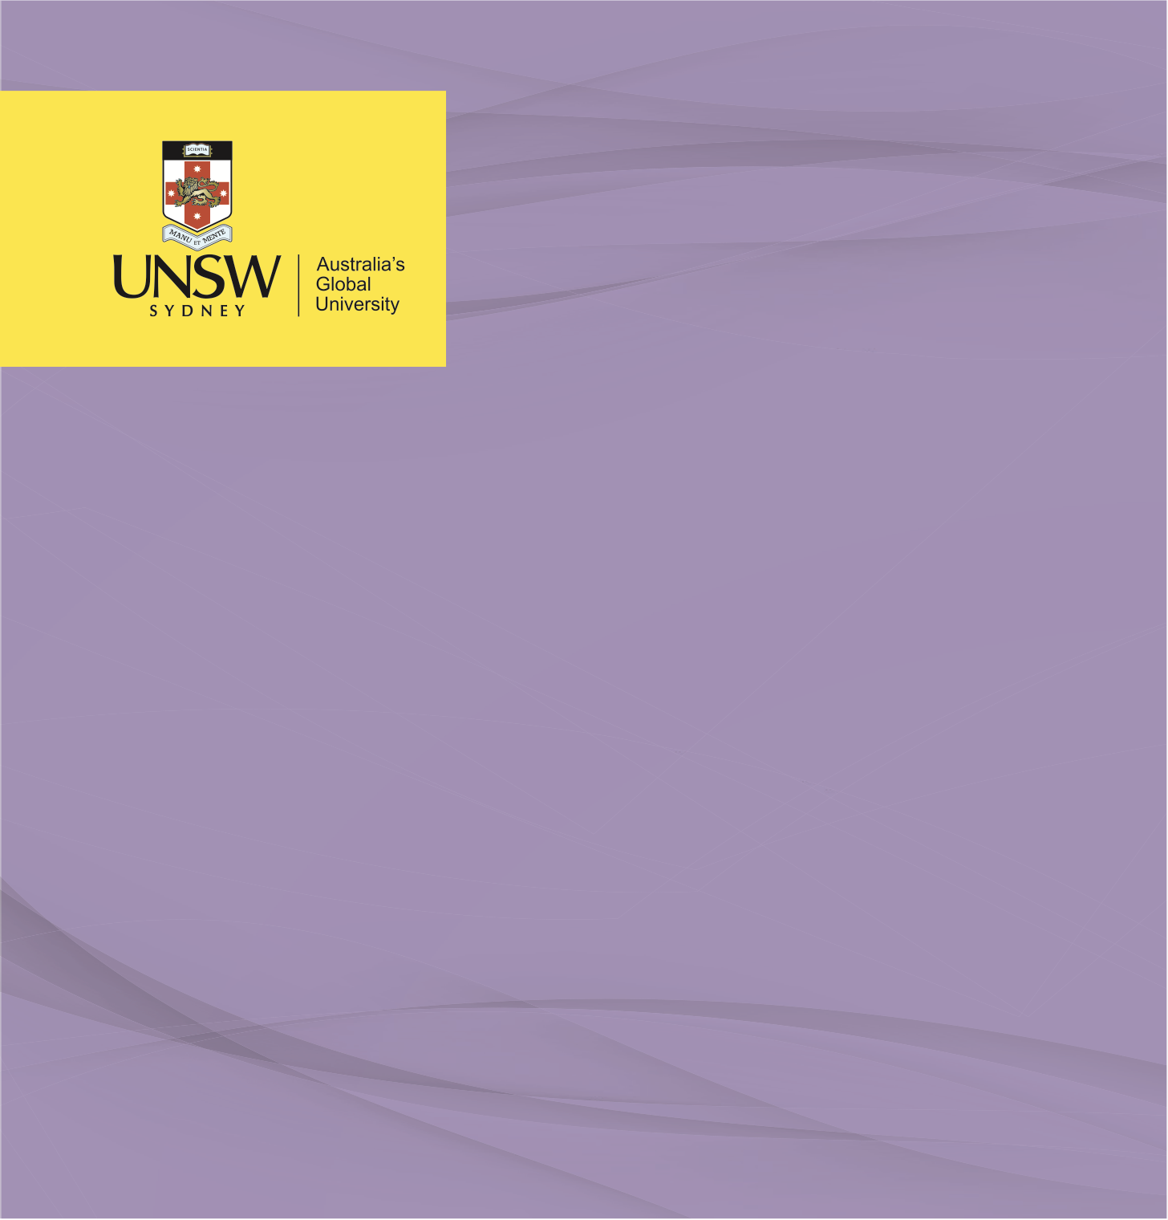

POLICY ANALYSIS

**Policy Analysis: Ethical Examination of the Cashless Welfare Card Program on Aboriginal and Torres Strait Islander Welfare Recipients**

**Ethics in Public Health**

Nicholas Tanner, July 2023

**An Ethical Examination of the Imposition of Cashless Welfare Cards on Aboriginal and Torres Strait Islander Welfare Recipients**

The Australian Government's hypothetical imposition of cashless welfare cards [CDC], aimed at ameliorating socio-economic disparities within Aboriginal and Torres Strait Islander communities, gives rise to significant ethical considerations. This prospective policy has been trialled previously with a CDC initiative which commenced in 2016 in regions of Northern Queensland, Western Australia and the Northern Territory (Australian National Audit Office [ANAO], 2022). This prospective policy intervention, harbouring the intention to circumscribe recipients' fiscal expenditures on non-essential goods and services elicits a complex array of ethical considerations. Upon initiation, such a policy could ostensibly infringe upon the sphere of personal freedoms, thereby catalysing the emergence of a paternalistic dynamic. Consequently, it mandates an in-depth analysis of the interconnected ethical complexities within the landscape of public health.

The ethical contention surrounding the potential imposition of cashless welfare cards lies within its implications for personal liberty and autonomy. The policy, by its nature, could engender a paternalistic dynamic by significantly curtailing individual agency (Childress et al., 2002). This approach inherently contravenes Childress's principles of public health ethics, which underpin the necessity of employing the least coercive and most respectful means to achieve public health objectives (Childress et al., 2002). In doing so, this potential infringement may inadvertently spark a cascading effect, exacerbating pre-existing societal challenges within these communities.

Among the societal challenges that could be exacerbated are stigmatisation, social exclusion, and the exacerbation of socio-economic disparities. The stigmatisation process could be augmented through societal perceptions that welfare recipients are incapable of managing their finances responsibly, further driving social exclusion. Thus, the policy might also unintentionally deepen socio-economic disparities by disproportionately affecting those who are already marginalised within society.

These ethical dimensions underscore the critical need to evaluate both the anticipated benefits and potential adverse effects of the policy, and question the possibility of more equitable, less intrusive methods to achieve public health objectives. This perspective reiterates the principle of proportionality in public health ethics, which asserts that the extent of public health interventions should not supersede what is necessary to address the public health concern.

Empirical research on similar interventions presents a dichotomous perspective. Some studies suggest potential benefits, including improved financial management and reduced harm from substance abuse (Mavromaras et al., 2020). Yet, others underscore potential adverse outcomes, such as exacerbating feelings of disempowerment, societal stigma, and even increased financial stress (Orima Research, 2017).

Furthermore, evidence from existing trial regions in Australia reveals mixed and contested results. While some government-commissioned reports indicate reductions in alcohol consumption and gambling (Orima Research, 2017), critics argue that these reports over-rely on subjective perceptions and anecdotal evidence. Many argue that the program has led to increased financial hardship, stigma, and exacerbated mental health issues (Australian Human Rights Commission, 2017).

Indigenous public health experts emphasise the critical importance of strength-based approaches and caution against perpetuating deficit discourses in Indigenous public health (Dudgeon et al., 2014). By controlling expenditure, the prospective policy risks continuing a deficit discourse, which starkly contrasts with expert Indigenous counsel.

Kass's ethical framework underscores the necessity for justifying of public health interventions, with a particular emphasis on the principle of justice (Kass, 2001). The potential imposition of cashless welfare cards could inadvertently compromise this sense of justice by creating inequalities and perpetuating stigmatisation, whilst concomitantly imposing undue restrictions of individual freedoms.

Simultaneously, the Nuffield Council's stewardship model advocates for the reduction of health inequalities while assuring the protection of individuals' autonomy (Nuffield Council on Bioethics, 2007). The prospective policy, by potentially undermining personal autonomy, could instigate a conflict with these ethical frameworks.

These normative elements, combined with empirical evidence, allow us to critically introspect existing biases and assumptions. This introspection aids in achieving a more balanced interpretation of public health issues, promoting more equitable and ethical public health policies.

One common counter-argument posits that the implementation of cashless welfare cards is a utilitarian approach, potentially serving the greater good by mitigating harms related to substance misuse, gambling, and financial mismanagement among vulnerable populations (Mavromaras et al., 2020). These arguments underscore the importance of prioritising child welfare and the government's implied duty of care to protect the most vulnerable.

However, public health ethics necessitates a delicate equilibrium between individual liberties and collective welfare (Gostin & Powers, 2006). This line of reasoning risks oversimplifying the complexities of the socio-economic challenges experienced by Aboriginal and Torres Strait Islander communities. Thus, the potential paternalistic underpinning of this policy could infringe upon individual autonomy and rights. Consequently, it becomes paramount to scrutinise whether this potential benefit counterbalances the cost against its potential to exacerbate harm, including stigmatisation, disempowerment, and social exclusion.

In summation, while the hypothetical imposition of cashless welfare cards aims to enhance Aboriginal and Torres Strait Islander person’s welfare, it engenders significant ethical implications related to individual liberties, autonomy, justice, and stigmatisation. Recognising the importance of strength-based approaches that respect autonomy and cultural values is paramount when addressing health disparities within Indigenous communities. Thus, a more synergistic and culturally sensitive approach to welfare assistance, incorporating community input in decision-making, may provide a more ethical and efficacious resolution to improve welfare among Aboriginal and Torres Strait Islander welfare recipients.

**References**

Australian National Audit Office. (2022). The Implementation and Performance of the Cashless Debit Card Trial. https://www.anao.gov.au/work/performance-audit/implementation-and-performance-the-cashless-debit-card-trial-follow

Childress, J. F., Faden, R. R., Gaare, R. D., Gostin, L. O., Kahn, J., Bonnie, R. J., Kass, N. E., Mastroianni, A. C., Moreno, J. D., & Nieburg, P. (2002). Public health ethics: Mapping the terrain. *Journal of Law, Medicine &amp; Ethics*, *30*(2), 170–178. https://doi.org/10.1111/j.1748-720x.2002.tb00384.x

Dudgeon, P., Milroy, H., & Walker, R. (Eds.) (2014). *Working Together: Aboriginal and Torres Strait Islander Mental Health and Wellbeing Principles and Practice*. (2nd Edition ed.) Commonwealth of Australia. http://aboriginal.telethonkids.org.au/kulunga-research-network/working-together-2nd-edition-%281%29/

Gostin, L. O., & Powers, M. (2006). What does social justice require for the public's health? Public health ethics and policy imperatives. *Health affairs (Project Hope)*, *25*(4), 1053–1060. https://doi.org/10.1377/hlthaff.25.4.1053

Kass N. E. (2001). An ethics framework for public health. *American journal of public health*, *91*(11), 1776–1782. https://doi.org/10.2105/ajph.91.11.1776

Mavromaras, K., Moskos, M., & Mahuteau, S. (2020). Evaluation of the cashless debit card: Final evaluation report. Adelaide: Future of Employment and Skills research centre, University of Adelaide. https://www.researchgate.net/publication/349518706_Evaluation_of_the_Cashless_Debit_Card_in_Ceduna_East_Kimberley_and_the_Goldfields_region_-_Quantitative_Supplementary_Report

Nuffield Council on Bioethics. (2007). The Ethics of Public Health. *The Lancet*, *370*(9602), 1801. https://doi.org/10.1016/s0140-6736(07)61748-6

Orima Research. (2017). Cashless Debit Card Trial Evaluation: Wave 1 Interim Evaluation Report. Department of Social Services, Australian Government. https://www.dss.gov.au/sites/default/files/documents/03_2017/final_cdct_evaluation_-_wave_1_interim_evaluation_report_9_february_2017.pdf

Orima Research. (2017). Cashless Debit Card Trial Evaluation: Final Evaluation Report. Department of Social Services, Australian Government. https://www.dss.gov.au/sites/default/files/documents/08_2017/cashless_debit_card_trial_evaluation_-_final_evaluation_report.pdf

Australian Human Rights Commission. (2017). Submission No 30 to Senate Standing Committees on Community Affairs, *Social Services Legislation Amendment (Cashless Debit Card) Bill 2017*, 29 September. https://www.aph.gov.au/Parliamentary_Business/Committees/Senate/Community_Affairs/CashlessDebitCard/Submissions